

NATIONAL UNIVERSITY OF TECHNOLOGY ISLAMABAD
DEPARTMENT OF COMPUTER SCIENCE
DIGITAL LOGIC DESIGN LAB

Name | Bisma Fatima
Roll No | 36
Batch | 24
Section | A
Lab Number | 04
Instructor Name | Sir Haseeb
Date of Submission | March 20TH, 2025
Topic Covered | Simplification And Implementation of Boolean Expressions

Experiment 4
Simplification and Implementation of Boolean Expressions
Objective
- To understand the utilization of Boolean algebra in logic circuits.
- To write logic equation of a logic circuit from the logic diagram.
- Simplification of Boolean Expression K-Map.
Tools/Equipment Requirement
- ICs as required, Digital Electronics trainer.

Theoretical Explanation
A set of rules or Laws of Boolean Algebra expressions have been invented to help reduce the number of logic gates needed to perform a particular logic operation resulting in a list of functions or theorems commonly known as the Laws of Boolean Algebra.
Boolean Algebra is the mathematics we use to analyze digital gates and circuits. We can use these “Laws of Boolean” to both reduce and simplify a complex Boolean expression in an attempt to reduce the number of logic gates required. Boolean Algebra is therefore a system of mathematics based on logic that has its own set of rules or laws which are used to define and reduce Boolean expressions.
The variables used in Boolean Algebra only have one of two possible values, a logic “0” and a logic “1” but an expression can have an infinite number of variables all labelled individually to represent inputs to the expression, for example, variables A, B, C etc., giving us a logical expression of A + B = C, but each variable can ONLY be a 0 or a 1.
1. A+0 = A
2. A+1 = 1
3. A .0 = 0
4. A .1 = A
5. A+A = A
6. A+A’ = 1
7. A.A = A
8. A.A’ = 0
9. (A’)’ = A
10. A+AB = A
11. A+A’B = A+B
12. (A+B)(A+C) = A+BC
13. A’. B’ = (A+B)’
14. A’+B’ = (A.B)’

Lab Tasks
Q1: Prove above mentioned rules using ICs and digital trainer.

1. A+0 = A
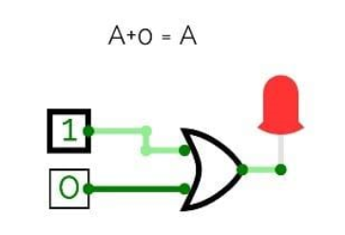

2. A+1 = 1
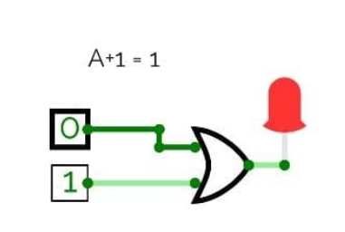

3. A .0 = 0
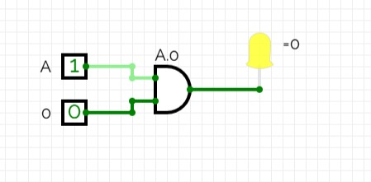

4. A .1 = A
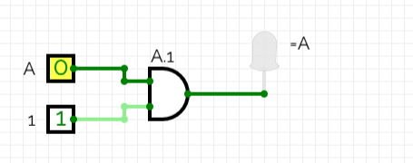

5. A+A = A
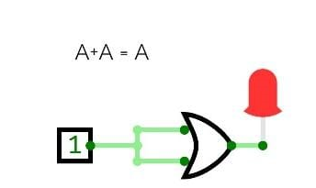

6. A+A’ = 1
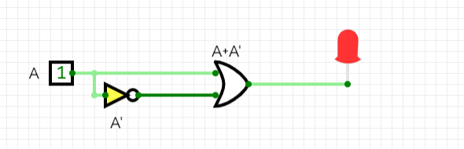

7. A.A = A
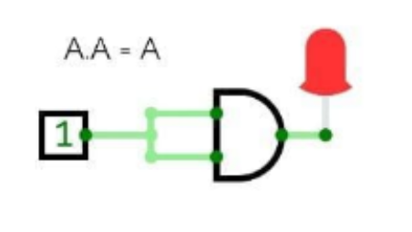

8. A.A’ = 0
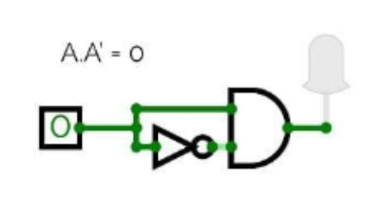

9. (A’)’ = A
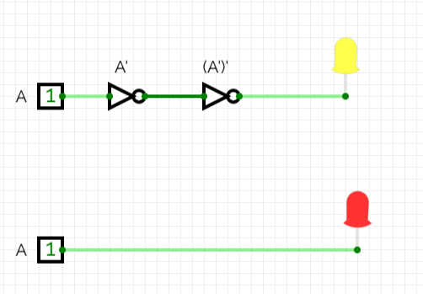

10. A+AB = A
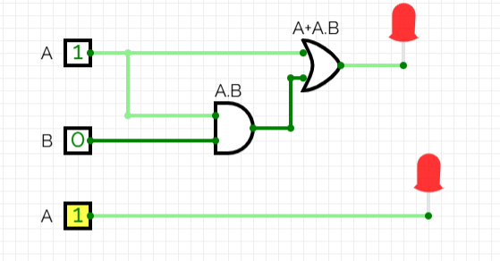

11. A+A’B = A+B
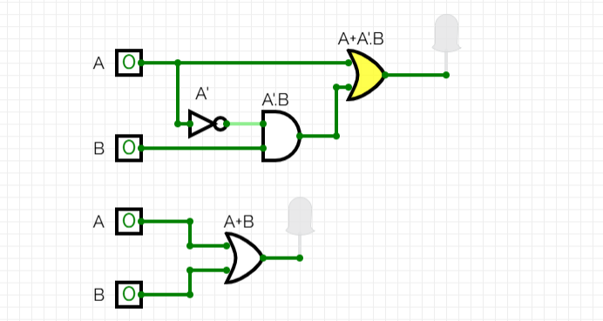

12. (A+B)(A+C) = A+BC
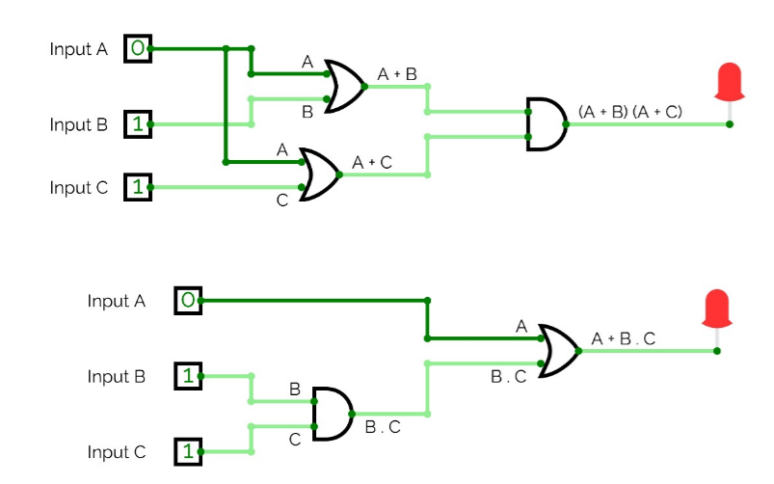

13. A’. B’ = (A+B)’
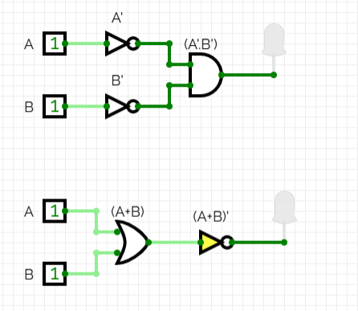

14. A’+B’ = (A.B)’
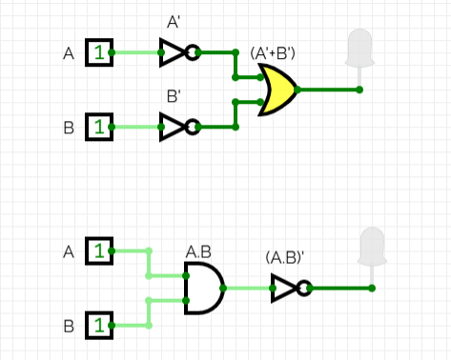

Q2:
Y = BC + BAD + BAD′
- Simplify the Expression using Boolean algebra.
Y=BC+BA(D+D’)
Y=BC+BA(1) : D+D’=1
Y=BC+BA
Y=B(C+A)
2. Draw the logic diagram for the original and simplified expression.
- Logical diagram for original expression
Y = BC + BAD + BAD′
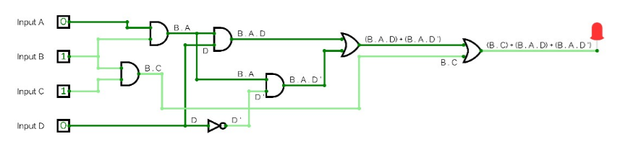
- Logical diagram for simplified expression
Y=B(C+A)
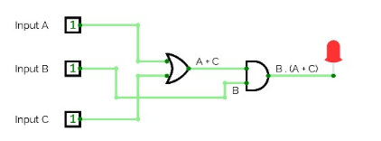
- Implement the circuit on trainer using the required logic gates.
- circuit diagram for original expression
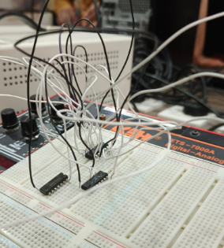
In original expression we used all three gate (and ,or ,not) to form the Boolean expression.
- circuit diagram for original expression
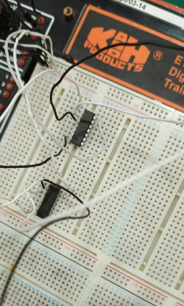
In simplified expression we used only two gate (and ,or ) to form the Boolean expression.

- Verify your circuit by applying all the possible input combinations to the circuit.
DONE IN LAB

- Complete the truth table for the original expression theoretically.

TRUTH TABLE FOR ORIGINAL
INPUTS |  |  |  | Expression  (Solve theoretically)
A | B | C | D | Y
0 | 0 | 0 | 0 | 0
0 | 0 | 0 | 1 | 0
0 | 0 | 1 | 0 | 0
0 | 0 | 1 | 1 | 0
0 | 1 | 0 | 0 | 0
0 | 1 | 0 | 1 | 0
0 | 1 | 1 | 0 | 0
0 | 1 | 1 | 1 | 1
1 | 0 | 0 | 0 | 1
1 | 0 | 0 | 1 | 0
1 | 0 | 1 | 0 | 0
1 | 0 | 1 | 1 | 0
1 | 1 | 0 | 0 | 1
1 | 1 | 0 | 1 | 1
1 | 1 | 1 | 0 | 1
1 | 1 | 1 | 1 | 1

- Construct a modified truth table for the simplified expression.

TRUTH TABLE FOR SIMPLIFIED

INPUTS |  |  | Expression  (Solve theoretically)
A | B | C | Y
0 | 0 | 0 | 0
0 | 1 | 1 | 0
0 | 1 | 0 | 0
0 | 1 | 1 | 1
1 | 0 | 0 | 0
1 | 0 | 1 | 0
1 | 1 | 0 | 1
1 | 1 | 1 | 1

Post Lab Task
Step 2
Y = ABC + AB′C + A′B
- Express it in the form of sum of min-terms.
The three terms in the given function contribute to the following minterms:
- ABC corresponds to minterm m7 (111)
- AB’C corresponds to minterm m5 (101)
- A’B corresponds to minterms m2 (010) and m3 (011)
Canonical Form:
Y = ∑(2,3,5,7)

- Draw the K-Map for the function.

A\BC | B’C’ (00) | B’C (01) | BC (11) | BC’ (10)
A’ (0) |  |  | 1 | 1
A (1) |  | 1 | 1

- Find its simplified expression from K-map in SOP form.
- GROUP 1=AB’C+ABC
- GROUP 2=A’BC+A’BC’
TAKING COMMON FROM BOTH;
Y=AC+A’B

4. Draw the logic diagram for the original and simplified expression.
- Logical diagram for original expression
Y = ABC+AB’C+A’B
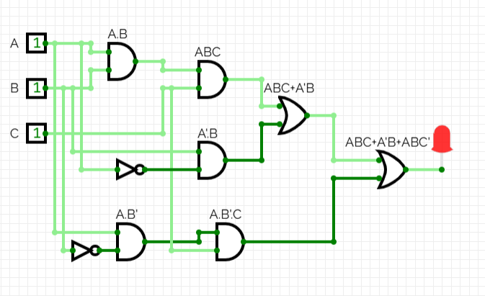
- Logical diagram for simplified expression
Y =AC+A’B
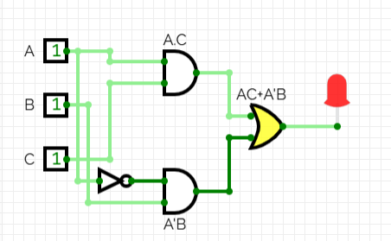
5. Verify your circuit by applying all the possible input combinations to the circuit.
DONE IN LAB
6. Complete the truth table for the original expression theoretically.
INPUTS |  |  | Expression  (Solve theoretically)
A | B | C | Y
0 | 0 | 0 | 0 (M0)
0 | 1 | 1 | 0(M1)
0 | 1 | 0 | 1(m2)
0 | 1 | 1 | 1(m3)
1 | 0 | 0 | 0(M4)
1 | 0 | 1 | 1(m5)
1 | 1 | 0 | 0(M6)
1 | 1 | 1 | 1(m7)

7. Construct a modified truth table for the simplified expression.

INPUTS |  |  | Expression  (Solve theoretically)
A | B | C | Y
0 | 0 | 0 | 0
0 | 1 | 1 | 0
0 | 1 | 0 | 1
0 | 1 | 1 | 1
1 | 0 | 0 | 0
1 | 0 | 1 | 1
1 | 1 | 0 | 0
1 | 1 | 1 | 1

